**Exercise 2.7:**

Simply change form method attribute to GET gives error: Undefined variables.

Change $_POST[...] in Form4Radio.php to $_GET[...] will fix this problem.

**Exercise 2.9:**

* DOM:

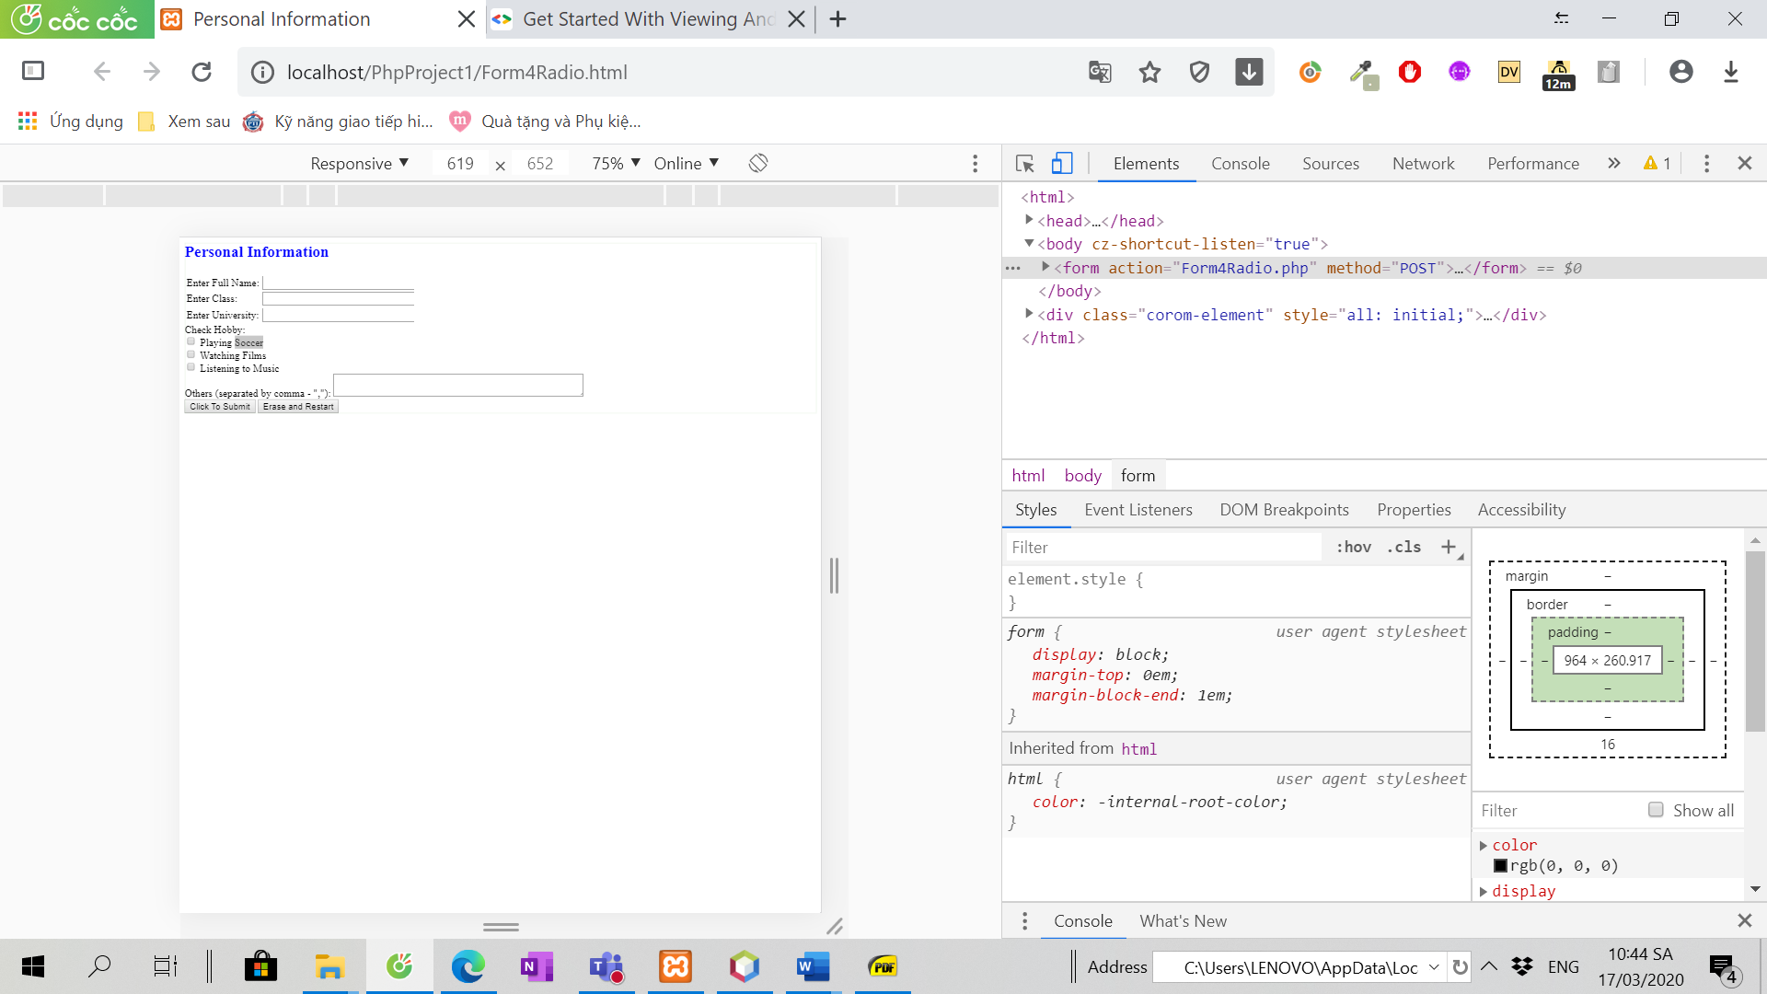

* HTML Source:

